FINAL PROJECT

Design and Construction of Analog and Digital 60-Hertz Notch Filters

Group M3
Ben Reidich
Lauren Costello
Noura Selim
Danielle Kuchinskas
Ange Wang

December 6, 2004

ABSTRACT

This experiment aims to design and construct an analog 60 Hz notch filter using a breadboard, the Universal Active Filter chip (UAF42 chip), and appropriate resistors. The filter was designed utilizing the Filter42 program, varying the Q parameter of Equation 1. The initial specification of Q =30 could not be realized due to breadboard limitations, as well as the fact that Equations 2 and 3 were not satisfied at Q>20 and a seventh resistor was required. Therefore, analog notch filters with Q values equal to 6, 10, and 15 were constructed instead.

In addition, a digital filter was designed using the algorithm derived by Barr and Chan. A calibration plot of fraction of unity versus Q showed that at 92.0% unity, Q = 6, at 94.5% unity, Q=10, at 96.5% unity, Q=15, and at 98.3% unity, Q = 29.3 (a Q for which an analog filter could not be realized). The frequency transfer function H(ω) was plotted as a function of frequency for several different percent unity values, demonstrating that as percent unity increases, the bandwidth decreases.

Comparison of the performance for the analog and digital filters revealed that not only is it possible to realize digital filters of high Q values (greater than 20), but such filters exhibit better characteristics as indicated by a thin bandwidth, steep attenuation, and constant gain at all frequencies other than the notch frequency (analog - Graph 1, digital - Graphs 4 to 8).

BACKGROUND

Filters, both analog and digital, have been designed and adapted for a myriad of applications. A notch filter, which is also known as a stop-band filter, is meant to filter out a specific unwanted frequency and allows signals to pass with no attenuation at all other frequencies. This filtered frequency is called the notch frequency. The notch filter is essentially a low-pass and high-pass filter placed in parallel. Additionally, an amplifier may be included to increase either the input or output. The other important characteristic of the notch filter is the width of the notch at the -3dB point (magnitude of the gain = 0.707). Smaller widths allow more specificity in what frequencies are filtered.

The ratio of the notch frequency to the notch width is termed Q and is the common specification given along with the notch frequency. The notch filter constructed was built to filter out 60Hz frequencies and would be useful for filtering out power line frequency and its harmonics. This is one of the most common uses of notch filters. In addition to dealing with the problem of power line noise in signals such as an electrocardiogram (ECG), notch filters are often used to remove the 60 Hz hum that can be found in audio signals.

Analog filters have been very popular in the past before the huge advancements in computing and small digital data acquisition systems, and are still utilized for certain applications. However, the analog filters tend to be less advantageous than their digital counterparts since their operating characteristics may vary with age and they frequently have non-linear phase shifts. Digital filters have become increasingly prevalent over the last several decades as computing power has increased allowing the storage and analysis of biosignals and other signals in a computer database. The two main drawbacks of the digital filter are the processing power and memory necessary to do real time processing. Digital filters are excellent if a twenty second diagnostic ECG signal is needed. Much longer signals would require an unreasonable amount of storage and so are better filtered with analog filters. Another limitation on digital filters is restrictions on sampling rate. They should not be used unless sufficiently high sampling rates can be achieved to overcome the problem of aliasing.

Additionally, filters are now being developed which are neither digital nor traditional analog. These filters rely on the natural oscillation frequency of magnetic materials to impede certain frequency components.

METHODS

- Using Filter42.exe, a 60 Hz notch filter was designed, using Q values of 6, 10, and 15.
- To realize the filters, a UAF42 chip and appropriate resistors were used.
- The resistors were connected in series on the breadboard to approximate the values indicated by Filter 42.
- All leads and connecting wiring were kept short, to minimize parasitic effects.
- The filter was constructed and gain values were obtained over a full spectrum of frequencies (1 – 360Hz) and frequency vs. gain graphs were constructed (Bode Plots).
- A digital 60 Hz notch filter was realized by applying the algorithm derived by Barr and Chan.
- Microsoft Excel was used to input sine functions to the digital filter.
- Frequency transform functions were plotted versus frequency and a calibration graph of unity versus Q was obtained.

DATA AND RESULTS

Figure 1
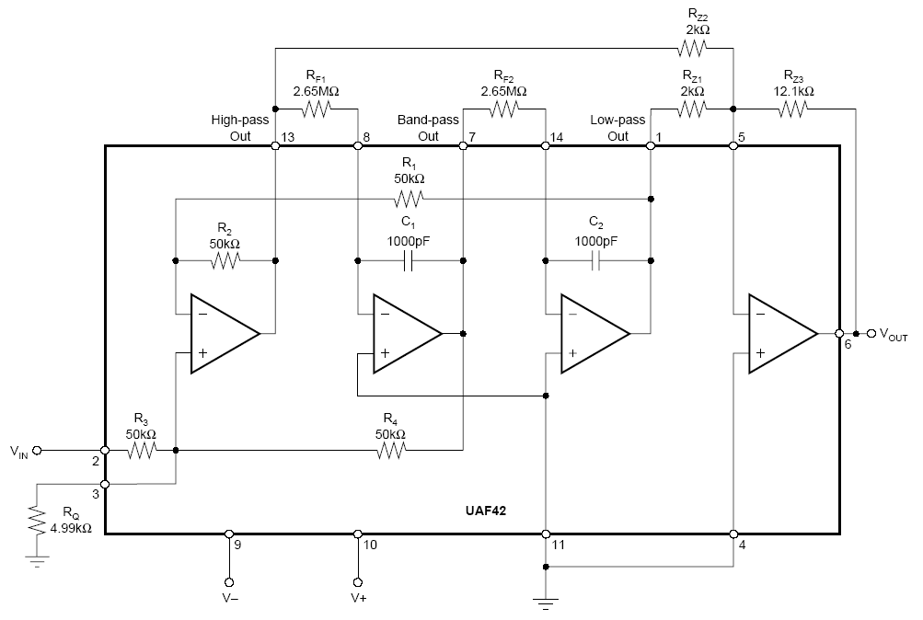
Figure 1 shows a schematic of the notch filter created using a UAF42 chip and 6 resistors (R_{F1}, R_{F2}, R_{z1}, R_{z2}, R_{z3}, and R_{Q}). Resistor values in the figure represent those used for Q=6.

Figure 2
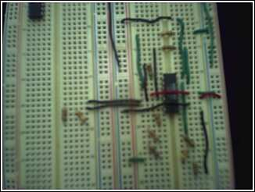
Figure 2 shows a 60-Hz analog filter built using the UAF42 chip, a breadboard and six resistors of values dictated by Filter42. See table 1 for resistor values.

Equation 1
Q = f_{notch} / BW_{-3 dB}

Equation 1 relates the notch frequency to the band width at -3dB by the filter parameter Q.

Table 1
Q | R_{z1} | act R_{z1} | R_{z2} | act R_{z2} | R_{z3} | act R_{z3} | R_{F1} | act R_{FI} | R_{F2} | act R_{F2} | R_{Q} | act R_{Q}
6 | 2KΩ | 1.965KΩ | 2KΩ | 1.976KΩ | 12.1KΩ | 11.71KΩ | 2.65MΩ | 2.618MΩ | 2.65MΩ | 2.639MΩ | 4.99KΩ | 5.05KΩ
10 | 2KΩ | 1.96KΩ | 2KΩ | 1.98KΩ | 20KΩ | 19.44KΩ | 2.67MΩ | 2.675MΩ | 2.67MΩ | 2.675MΩ | 2.8KΩ | 2.77KΩ
15 | 2KΩ | 2KΩ | 2KΩ | 1.99KΩ | 30.1KΩ | 30.22KΩ | 2.67MΩ | 2.692MΩ | 2.67MΩ | 2.665MΩ | 1.78KΩ | 1.74KΩ
30 | 20KΩ | _--- | 2KΩ | --- | 191KΩ | --- | 825KΩ | --- | 825KΩ | --- | 487KΩ | ---

Table 1 shows the resistors used for various Q values found with the Filter 42 program as well as the actual resistor values implemented. Note that actual values for Q=30 are not present because a Q=30 filter was not constructed.

Equation 2
$$R_{Q}=\frac{\text{25}KΩ}{Q−1}$$

Equation 3
$$Q=\frac{R_{Z3}}{R_{Z1}}=\frac{R_{Z3}}{R_{Z2}}$$

Equations 2 and 3 exhibit the requirements that must be satisfied in order to implement the filter. Note: Equations 2 and 3 were satisfied only for Q values less than 20.

Graph 1
Graph 1 shows the gain response for the 60 Hz notch analog filter, Q = 6, Q=10, Q=15
60 Hz Notch Filter
0
0.2
0.4
0.6
0.8
1
1.2
0
20
40
60
80
100
120
Frequency (Hz)
Gain
Q=6
Q=10
Q=15

Digital Filter
Algorithm

If f_{s} = 400, then:
$θ=±\frac{2π\text{60}}{2π\text{400}}∗\text{360}°$
$$θ=±\text{54}°$$

Zeroes of the functions are:

$$\begin{aligned}z_{1,2}=\text{cos}(\text{54}°)±j\text{sin}(\text{54}°) \\ z_{1,2}=\text{.}\text{5878}±j\text{.}\text{8090}\end{aligned}$$

At 95% unity**, the poles are:

$$\begin{aligned}p_{1,2}=\text{.}\text{95}[\text{.}\text{5878}±j\text{.}\text{8090} \\ p_{1,2}=\text{.}\text{5584}±j\text{.}\text{7686}\end{aligned}$$

The z transfer function is:

$$H(z)=\frac{(z−\text{.}\text{5878}+j\text{.}\text{8090})(z−\text{.}\text{5878}−j\text{.}\text{8090})}{(z−\text{.}\text{5584}+j\text{.}\text{7686})(z−\text{.}\text{5584}−j\text{.}\text{7686})}$$

With the reduced canonical form:

$$H(z)=\frac{1−1\text{.}\text{175}z^{−1}+z^{−2}}{1−1\text{.}\text{117}z^{−1}+\text{.}\text{903}z^{−2}}$$

The recursive algorithm becomes:

$$y_{n}=x_{n}−1\text{.}\text{175}x_{n−1}+x_{n−2}+1\text{.}\text{117}y_{n−1}−\text{.}\text{903}y_{n−2}$$

**By changing the percent unity, the coefficients will vary, thus different values of Q can be obtained. As the poles approach the zeroes (i.e. approach 99% unity), the Q value increases.

Graph 2
Graph 2 shows the output sine wave of a digital 60 Hz notch filter at 50 Hz (Q = 8.82). The sampling frequency is 400 Hz. As expected, the amplitude is approximately one.

Graph 3
Graph 3 shows the output sine wave of a digital 60 Hz notch filter at 60 Hz (Q = 8.82). The sampling frequency is 400 Hz. The filter causes a significant decrease in amplitude of the sine wave at 60 Hz.

Graph 4

Graph 4 shows H(ω) versus frequency for the 60-Hz digital notch filter with Q = 8.82, corresponding to Graphs 2 and 3, above. As expected, a sharp notch occurs at 60 Hz. The band width can be varied by choosing different fractions of unity, with higher fractions yielding smaller band widths.

Graph 5
Graph 5 was obtained by varying the fraction of unity and thus Q, to obtain 98.3% unity and Q = 29.53. The blue dotted line corresponds to -3 dB attenuation (.707 of the maximum). Note: An analog filter with Q=30 could not be realized.

Graph 6
Graph 6 corresponds to 92% unity and Q = 6, which are the specifications of the analog filter constructed. An analog filter with Q=6 is shown in Graph 1.

Graph 7
Graph 7 corresponds to 94.5% unity and Q = 9.74, which are the specifications of the analog filter constructed. An analog filter with Q=10 is shown in Graph 1.

Graph 8
Graph 8 corresponds to 96.5% unity and Q = 14.93, which are the specifications of the analog filter constructed. An analog filter with Q=15 is shown in Graph 1.

DISCUSSION

Initially, the aim was to construct a 60 Hz notch filter with Q=30 as instructed. Such a notch filter would only filter out a single unwanted frequency (60 Hz in this case). All other frequencies would pass unattenuated by such a filter. In order to construct the notch filter, two steps must be performed. The first is the actual design of the filter. This was done in Filter42.exe, a program that dictated the resistor values necessary to build a notch filter with the above specifications. To realize the chip design, a Universal Active Filter chip (UAF42) was used. The UAF42 chip has several operational amplifiers and other components built into it and therefore it can be used with the addition of only 6 resistors and a power supply, the minimum number of additional components, to provide the filtration properties required.

The original specification of Q=30 could not be realized for several reasons. The values supplied by Filter42.exe for Q values above 20 did not satisfy Equations 1 and 2. Filter42 also indicated that a seventh resistor should be used at higher Q values. It was unclear how this resistor should be implemented. Another problem was introduced by using the breadboard, which introduces a considerable amount of capacitance from internal components. 60 Hz notch filters having Q values of 6, 10 and 15 were successfully constructed instead, although the bode plot began to exhibit an increase in gain just prior to roll-off for Q=15. Parasitic capacitance, inductance, and noise that may be picked up were effectively reduced when realizing those filters. This was done by keeping all the leads as short as possible. Soldering resistors together to achieve resistors having the values dictated by Filter42 was also avoided, and instead, multiple resistors were connected in series on the breadboard. Resistor values were measured using a multimeter to increase accuracy. It may be possible that if a higher quality breadboard were used, it would have been possible to realize notch filters with higher Q values. Also, if exact resistor values were available, multiple resistors would not have to be connected in series and thus parasitic effects would have been further reduced.

The digital filter was realized by applying the algorithm derived in Barr and Chan’s Design and Implementation of Digital Filters for Biomedical Signal Processing. The first step in designing the digital filter was to work through the algorithm with a sampling frequency of 400 Hz. The zeroes and poles are obtained and then the coefficients of the recursive formula were found. The output sine wave functions were obtained by direct implementation of the recursive formula. Frequencies plugged into this formula yielded sine waves of varying amplitude, particularly if close to the notch frequency of 60 Hz where amplitude was low. This is demonstrated by Graphs 3 and 4.

Bode plots for the digital notch filter were constructed in MathCad. The coefficients were plugged into the canonical formula and graphed versus frequency, yielding a Bode plot. The bandwidth of the Bode plot, and thus Q of the digital filter, was manipulated by varying the percent unity of the poles. To determine this relationship, percent unities ranging from 95% to 99% were graphed as Bode plots in MathCad and the bandwidths were obtained. These were converted to Q via the relationship in Equation 1. It was found that a Q of 6 corresponded to a percent unity of 92% and a Q of 30 (the initial goal of the experiment) corresponded to a percent unity of 98.3%. The digital filter easily attained a Q of 30, while the analog filter could not realize this.

Graph 1 shows the responses of the 60 Hz notch filters at the different Q values super-imposed on one another. It is clear that at higher values of Q, bandwidth decreases, as predicted by Equation 1. Graphs for Q=6 and 10 show a constant gain up until the notch frequency of 60 Hz, where a rapid roll-off is observed. However, Q=15 demonstrates an increase in gain over a brief range of frequencies prior to roll-off. Ideally, a Bode plot for a notch filter should have a thin bandwidth, steep attenuation, and show constant gain at all frequencies other than the notch frequency. As aforementioned, the analog filter Bode plots do not completely satisfy these characteristics for all Q values. However, the digital filter Bode plots (Graphs 4-8) do satisfy these specifications. As bandwidth decreases, there is no trade-off between constancy of the gain for frequencies surrounding 60 Hz. It can be concluded from the results of this experiment that a digital filter is more advantageous than its analog counterpart, though may not be practical for applications requiring long periods of data collection.

If time permitted, a potentiometer could have been incorporated in series with some of the resistors so that the circuit could be tuned. In the future, it would also be beneficial to include a voltage follower which can be used to greatly increase Q (from .3 to 50) or to create an adjustable notch filter, as described by National Semiconductor. However, doing so may not allow for the use of the UAF42 chip and would only be appropriate if more time were allowed.

As previously mentioned, a common application of notch filters is the removal of power line noise in order to obtain cleaner biomedical signals. In these signals, power line frequencies usually occur around 50 or 60 Hz and are often the largest source of noise, since biosignals typically have relatively low amplitudes. Low pass filters are often not appropriate to use because not all frequencies occur below the cutoff frequency. Ferdjallah and Barr discuss the application of three types of notch filters to a biosignal: second-order adaptive, fixed-zero adaptive, and non-fixed pole zero adaptive second-order. Adaptive notch filters are used when the characteristics of a signal depend on time and also when the power line interference has a Gaussian distribution about a frequency. On the other hand, a fixed notch filter is used when the noise is located exactly at a certain frequency. The study found that the non-fixed pole zero adaptive filter is the most efficient at eliminating noise, due to the fact that it can minimize filter width by changing the coefficients of the filter that are affected by the bandwidth. It was also found that adaptive filters are better at eliminating noise than fixed notch filters, suggesting the power line frequencies are not fixed at one exact frequency, but rather have a Gaussian distribution. In addition to biosignals, notch filters have a wide range of applications in cell phones, radar, wireless communication, and other signals systems.

Barr, Ronald E., Chan, Erik Y. Design and Implementation of Digital Filters for Biomedical Signal Processing. Journal of Electrophysiol. Tech. Pergamon Press Ltd., Vol. 13. pp 73-93. 1986.
Celinski, R. E. Camley, T. M. Chritianson High Frequency Signal Processing Devices for Security Aplications: Band Pass and Notch Filters, Z., Center for Magnetism and Magnetic Nanostructures, University of Colorado, http://web.uccs.edu/research/highfrequencysignalprocessi.pdf
Barr, Ronald E., Chan, Erik Y. Design and Implementation of Digital Filters for Biomedical Signal Processing. Journal of Electrophysiol. Tech. Pergamon Press Ltd., Vol. 13. pp 73-93. 1986.
Molina, Johnnie. Design A 60Hz Notch Filter With The UAF42
BE 309 Lab Manual, Experiment 8, Design and Analysis of a Butterworth Lowpass Filter
High Q Notch Filter, National Semiconductor, Linear Breif 5, Match 1969, http://www.national.com/ms/LB/LB-5.pdf
Barr, Ronald, Ferdjallah, Mohammed. Adaptive Digital Notch Filter Design on the Unit Circle for the Removal of Power line Noise from Biomedical Signals. IEEE Transactions on Biomedical Engineering, Vol. 41, No. 6, June 1994.

