BE 309 FINAL LAB PROJECT

Design and test a 60Hz analog notch filter using a UAF42 universal filter module.

GROUP T4
Jiamin Ng
Bistari Muhammad
Shun Loong Chua
Jinghao Kuang

DATE: December 11th 2004

A. Abstract

In this experiment, an analog 60Hz “notch” filter (with Q = 30) was built using an UAF42 chip on a breadboard circuit while a digital 60Hz “notch” filter (Q = 30) was designed using MathCad. The properties of the analog and digital filters were compared against that of the specifications they were designed for. Specifically, the analog filter had a notch frequency of 60.23Hz with a -3dB bandwidth of 2.13Hz and a Q value of 28.3. For the digital filter with unity value 0.985, the notch frequency was found to be 60.00Hz with a bandwidth of 2.00Hz and Q value of 30.0.

In addition, the analog and digital filters were also compared against each other to determine their relative advantages and disadvantages. In particular, the digital filter is observed to have a steeper cutoff than the analog filter due to its higher Q value and high R value, and thus is more precise in removing 60Hz powerline noise.

B. SPECIFIC AIMS AND OBJECTIVES

- Design and build a 60 Hz “notch” filter with Q = 30 using the UAF42 active filter chip.
- Breadboard the circuit and measure its properties to verify that our design meets the specifications
- Design a digital notch filter of the same specifications and analyze its properties.
- Compare the properties and performance of the analog and digital notch filters.

C. BACKGROUND AND THEORY

60Hz powerline frequency and its problems

The power line frequency of 60Hz causes interference and contamination of the signals obtained in biomedical applications. In practice, low pass filters could be used to filter out the 60Hz noise since most biological signals are usually below 60Hz. This approach works well for low resolution functions. For example, in the monitoring mode for ECGs, only a frequency response of 0.5 to 40Hz is needed to provide sufficient resolution.

However, for higher resolution modes like the diagnostic mode, a high-frequency limit of 100 Hz is required to ensure that the tracings allow assessment of QRS morphology and tachyarrhythmias. Using a lowpass filter at 60Hz will result in the loss of the signals with frequency greater than 60Hz. Consequently, a new filter design is required to overcome this problem.

The notch filter

The 60 Hz notch filter was a filter capable of solving the problem. It is a combination of both high pass and low pass filters, where the lowpass and high pass outputs are summed to give a final output signal. In this way, it is possible to eliminate the 60 Hz noise without deleteriously affecting signal integrity.
Initially, analog versions of the notch filter were used, but this imposed many limitations. For example, the notch filter must be applied on the signal before it is recorded. However, with the increase in computing power, digital filters were designed that were capable of performing analog notch filter functions before and also after the signal has been recorded.

The UAF42 universal filter module

In building the analog notch filter, the UAF42 filter module was used in conjunction with appropriate carbon resistors and put together on a breadboard.

In particular, the UAF42 is a monolithic, time-continuous, 2nd-order active filter building block for complex and simple filter designs. It uses the classical state-variable analog architecture with a summing amplifier plus two integrators. This topology offers low sensitivity of filter design parameters F_{o} (natural frequency) and Q to external component variations along with simultaneous high-pass, low-pass and band-pass outputs.

C. MATERIALS

- MATHCAD software
- Collection of 5% carbon resistors
- Solderless breadboard
- UAF42 filter module
- Labview

D. METHODS

Building the analog filter

The analog notch filter was built from a UAF42 chip and various carbon resistors on a bread board. The notch frequency is given by:

f_{NOTCH} = √(A_{LP} / A_{HP} • R_{Z2} / R_{Z1}) • f_{O}

where
A_{LP} = gain from input to low-pass out at f = 0Hz
A_{HP} = gain from input to high-pass out of f>>f_{O}

We want A_{LP} and A_{HP} to be equal so that the gain around the notch is symmetrical and also equal to 1. R_{Z2} and R_{Z1} are also equal. This results in ( A_{LP} / A_{HP} • R_{Z2} / R_{Z1} ) being equal to 1. Therefore,

f_{NOTCH} = f_{O}

Since,
f_{O} = 1 / ( R_{F} • C • 2π )

where R_{F}= R_{F1} = R_{F2} and C = C₁ = C₂ = 1000pF

Therefore, R_{F} = 1.592x10⁸ / f_{NOTCH}

To get a notch frequency of 60Hz, we used a R_{F} of 2.65MΩ.

Q is the ‘quality’ of the notch filter and determines how steep the cutoff is. It is determined by the ratio,

Q = R_{Z3}/R_{Z1} = R_{Z3}/R_{Z2}

To get a Q of 30, we set R_{Z1} = R_{Z2} = 2kΩ and R_{Z3} = 60kΩ.

R_{Q} is determined by the formula,

R_{Q} = 25kΩ / (Q-1)

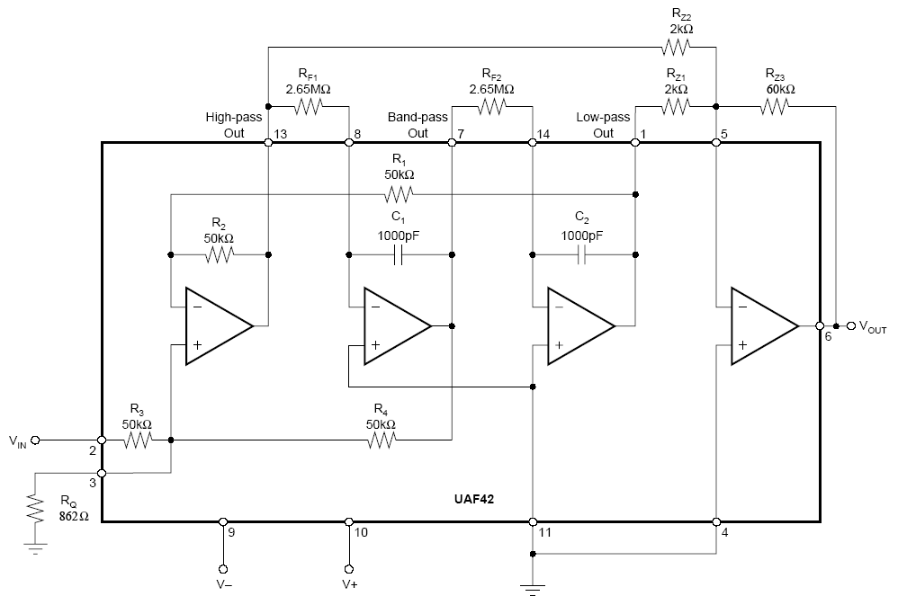
Diagram 1. Full diagram of the analog 60Hz notch filter with a Q of 30. The dark black box is the UAF42 chip and all resistors outside the box are carbon resistors.

Since the actual resistance of the carbon resistors does not always match the designated value, we measured their actual resistance with a multi-meter (for values refer to table 1). Using the actual values of the resistances, we recalculated the expected f_{NOTCH} and Q of the analog notch filter (for values refer to table 2).
To test our analog notch filter, we put in sine waves at different frequencies and measured the output frequencies and gain using Labview. The gain was then plotted against frequency to obtain the frequency response curve of the analog notch filter.

The actual f_{NOTCH} is determined by extrapolating the two slopes beside the notch in the frequency response of the notch filter to zero and finding the average value.

The actual Q is calculated by the formula,

Q = f_{NOTCH} / BW_{-3dB}

Where BW_{-3dB} is the -3dB bandwidth, which is defined as f_{H} – f_{L}
Where f_{H} is the high -3dB cutoff frequency and f_{L} is the low -3dB cutoff frequency.

f_{H} and f_{L} were determined by plotting the frequency response of the notch filter together with a -3dB line, and finding the frequencies at which they intercept.

Building the digital filter

The purpose of this section is to design a 60 Hz digital Notch filter and to compare the properties of the digital filter to that of a similar analog Notch filter. The digital filter was designed using MathCad, and tested using sine waves with varying frequencies as the inputs. The filter was then run on an EKG sample of sampling rate of 400 s⁻¹ and the effects of the digital filter on the output were recorded and compared using the Fast Fourier Transform (FFT) of the filtered and unfiltered signals. The signal was sampled at intervals (T) of 0.0025s, which produced a sampling rate of 400 s⁻¹ . The quality, the ratio of the central frequency (60Hz) to the -3 dB difference in the notch (Q), was set at 30.

To set up the digital filter, the angle (θ rad) which determines the zero positions on the unit circle perimeter is found by:
(1)
Substituting into equation (2), C1 and being the poles, and reducing the frequency transfer function (H(f)) to its canonical form (equation (3)), the coefficients can be used to determine Y(z), by comparing them to equation (4).

(2)

H(z) = (1 – 1.1756z⁻¹ + z⁻²) / (1 – 1.1579z⁻¹ + 0.9702z⁻²) (3)

(4)
where , and f is the frequency.

Using a sine wave input of x(t) = sin(2πft), and by varying the frequency, |H(f)| was plotted against f to test the effects of the digital filter (figure3).

R, the percentage unity of the filter, is determined by the quality (Q) of the filter. The values of R were varied and the respective Q-value from the resulting graph of |H(f)| against f were calculated and recorded. By plotting R against Q (figure 4), the appropriate R-value is found by solving for R when Q = 30. For Q = 30, R is found to be 0.985. Substituting the values into equation (2), the recursive algorithm is derived to be:

(4)

The 60Hz digital Notch filter was then applied to an EKG sample of sampling rate 400 s⁻¹ and the effects of the filter were observed (figure 5). A Fast Fourier Transform (FFT) was applied on the EKG sample, the filtered results, and the stable portion of the filtered results, and the resultant graphs were compared (figures 6 i, ii, iii).

E. RESULTS

Figure 1. The frequency response of the analog filter built. The shape is characteristic of a notch filter, where there is a very steep cutoff near f_{NOTCH}. However, the gain at frequencies below 60Hz is not symmetrical with the gain at frequencies above 60Hz.

Figure 2. The -3dB line is plotted on an enlarged filter response curve to determine f_{H} (61.55) and f_{L}(59.42) at the intersection points. The bandwidth BW_{-3dB} is 2.13Hz while the notch frequency was 60.24Hz. Q is 28.3.

 | Target Resistance / Ω | Actual Resistance / Ω | Resistors Used / Ω
R_{F1} | 2.65M | 2.65M | 4.7k , 1.6M , 1M
R_{F2} | 2.65M | 2.65M | 4.7k , 1.6M , 1M
R_{Z1} | 2k | 1.99k | 2k
R_{Z2} | 2k | 2.01k | 2k
R_{Z3} | 60k | 59.7k | 33k, 27k
R_{Q} | 862 | 861 | 330, 270 X 2
Table 1. This is the table of the desired resistance vs the actual resistance as measured by a multi-meter, and the number and labeled resistance of resistors used.

 | Desired | Expected | Actual
f_{NOTCH} | 60Hz | 60.1Hz | 60.23
BW_{-3dB} | 2Hz | 2.01 | 2.13
Q | 30 | 29.9 | 28.3
Table 2. This table shows the desired specifications we designed the analog notch filter with, the expected specifications based on the actual resistance measured by a multi-meter and the actual specification as measured experimentally.

Figure 3. shows the magnitude of the frequency transfer function (|H(f)|) plotted against various frequencies to determine the frequency response of the digital filter. The dotted line shows the -3dB cutoff line. A tracer function was used to calculate BW_{-3dB} which is 2.00Hz. f_{NOTCH} was determined to be exactly 60.00Hz.

Figure 4. Shows the relationship between the quality (Q) against the R-value, which was found to be Q = 137568R² – 268807R + 131333. Q was calculated from figure 3 as the ratio between the central frequency (60Hz) to the -3dB bandwidth. A Q-value of 30 was found to correspond with an R-value of 0.985, which was substituted into equation (2).

Figure 5. Shows the effect of the digital filter on an EKG sample of 1.5s, with sampling rate 400 s⁻¹. The stable filtered EKG signal shows a significant decrease in noise compared to the original EKG sample. However, the EKG is still rather noisy. The filtered signal from 0 to 0.15s was much more erratic due to the instability of the initial output.

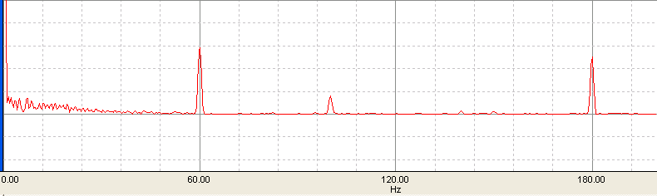
Figure 6i. Unfiltered

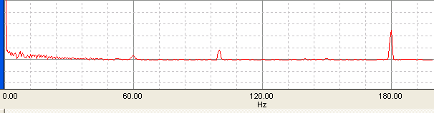
Figure 6ii. Filtered

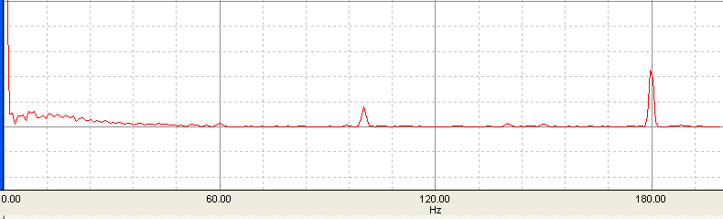
Figure 6iii Filtered with Ringing Effect Removed

Figure 6. Figures 6 i, ii and iii show the FFT graphs for the unfiltered signal, the filtered signal and the filtered signal with the initial signal removed respectively. The peak at 60Hz was the greatest in the unfiltered signal, then the filtered signal, and the smallest peak at 60 Hz was in the filtered signal with ringing effect removed. Other peaks were observed at 100Hz and 180Hz in all 3 FFT graphs.

F. DISCUSSION AND ANALYSIS

Asymmetry of gain in analog notch filter
The frequency response of an ideal analog notch filter is supposed to be symmetrical about the notch frequency of 60Hz (refer to appendix 1). From figure 1 however, it can be seen that the frequency response curve about the notch frequency for the analog filter built is not symmetrical. The average gain from 0Hz to 50Hz was 1.014 while the average gain from 70Hz to 120Hz was 1.003, which translates into a difference of 1.1%.

This is probably due to the actual values of resistance used for R_{Z1} and R_{Z2}, which were 1.99KΩ and 2.01kΩ respectively as measured by a multi-meter. The notch filter works by summing the outputs of a low-pass and a high-pass filter, whose gain are affected by R_{Z1} and R_{Z2} respectively. This relation can be seen in diagram 1, where R_{Z1} is connected to the low-pass out and R_{Z2} is connected to the high-pass out. The difference in the actual resistance of R_{Z1} and R_{Z2} is exactly 1%, which very closely matches the 1.1% difference in gain on both sides of the notch, and thus is a very possible explanation for the asymmetry in the gain on opposite sides of the notch.

Actual f_{NOTCH} and Q of analog notch filter
The f_{NOTCH} of the analog notch filter was determined to be 60.23Hz, which was higher than the expected value of 60.1Hz based on the actual resistances measured in table 1. This could be a result of the difference in gain on both sides of the notch, which were in turn due to difference in actual values of resistances of R_{Z1} and R_{Z2} as described above. Below f_{NOTCH}, the gain was relatively higher, thus setting f_{L} higher than expected. Above f_{NOTCH}, the lower gain allowed f_{H} to be higher than expected. This combination could have resulted in f_{NOTCH} being greater than the expected value of 60.1Hz.

The Q value of the analog notch filter was determined to be 28.3, which is lower than the expected Q of 29.9. This is a consequence of the cutoff bandwidth (BW_{-3dB}) of 2.13Hz being higher than expected. BW_{-3dB} was larger than expected as f_{H}’s +0.55Hz deviation from the expected value is larger than f_{L}’s +0.42Hz deviation as seen in figure 2. It could be due to the slightly different gains about the notch, which is due to the difference in R_{Z1} and R_{Z2}. Another possible reason is that parasitic capacitance in the carbon resistors affects the gain in higher frequencies hence contributing to the different deviations in the attenuation of the frequencies that passes through the low-pass and high-pass filters which compose the analog notch filter.

Exact resistances vs no. of resistors
In order to build a filter that most closely meets the specifications desired, it was ensured that the resistors used had the right calculated resistance. However, that is not always the case as it is difficult to find carbon resistors that had the exact matching resistance. Although it was always possible to mix and match different resistors to get the exact matching resistance, too many resistors would introduce too much parasitic capacitance which could affect the performance of the filter. Hence a compromise had to be made by using as little resistors as possible yet coming closest to the resistance desired. In our design, we limited the number of resistors used per resistor value to 3 (table 1). Further experiments can be conducted to quantify the effect of parasitic capacitance by designing filters and varying the number of resistors used in series while using the same total resistance.

Possible ways to improve the analog notch filter
Although the analog notch filter was built successfully and performed very close to expectations, the Q value of 28.3 was less than 30 while the notch frequency of 60.23Hz was more than 60Hz. The simplest and also the most significant way to improve the analog notch filter would be to use component resistors with the exact required resistances. This can be achieved by using resistor boxes to replace the carbon resistors that were used. It would also allow f_{NOTCH} and Q to be easily adjusted.

Actual f_{NOTCH} and Q of digital notch filter
The f_{NOTCH} of the digital notch filter was determined to be 60.00Hz while the Q value was determined to be 30.0, which was exactly the same as the designed specification. Accordingly, BW_{-3dB} was 2Hz exactly. The unity value R was 0.985, which is high and corresponded to the steep cut-off observed for the digital notch filter’s frequency response curve. The fact that the notch frequency and Q value met the design criteria exactly was expected since digital filters were designed using exact values and equations.

Performance of 60Hz digital notch filter on EKG signal
The FFT signals in figure 6 show that there were other peaks at 100Hz and 180Hz, which could be responsible for the remaining noise in the filtered signal output. Although the peak at 60Hz of the filtered signal in figure 6ii was much smaller than that of the unfiltered signal in figure 6i, there still was a significant peak, which differed from the expected results of having no peak after passing the signal through the digital filter. Possible reasons for this could be the result of the windows effect while applying the FFT, which would broaden the signal, and the initial vibration of the hardware, which is typically at 60Hz. The latter effect was removed by applying the FFT to the filtered signal after the signal stabilized at t>0.3s, hence removing the initial ringing effect. The resultant FFT in figure 6iii shows a smaller peak at 60Hz than the FFT of the entire filtered signal. This suggests that the initial ringing effect was a factor responsible for the peak at 60Hz of the filtered signal

Comparison of the ease of design and implementation of both types of filters
Designing an analog notch filter with any f_{NOTCH} and Q is straightforward using the UAF42 chip and calculating the various external resistances required. However, it is difficult to implement such a filter with the precision due to the difficulty in being able to get exact resistances required in configuring the chip to have the desired f_{NOTCH} and Q.

A digital notch filter on the other hand is much more precise, performing exactly as it is designed to. However, the design and implementation of a digital notch filter requires the use of a computer. Especially, the use of a high-performance computer is necessary if a real-time digital notch filter is desired to be put in use on data with a high sampling rate. Analog notch filters, however, does not require data to be digitized. Hence, sampling rate does not affect analog notch filters as sampling, if performed, is done after going through the filter. As a result, the implementation of digital notch filters in low cost devices such as audio speakers is often not practical, and where analog notch filters will be much more practical choice.

Comparison of the performance of both types of filters
It is clearly seen that the digital notch filter outperforms the analog notch filter by having both f_{NOTCH} and Q performing exactly at the original design of 60Hz and 30 respectively. However, the deviation from f_{NOTCH} and Q for the analog filter is only 0.4% and 5.7%. In practice, this small deviation is unlikely to cause a significant reduction in the capabilities of the analog notch filter from removing 60Hz noise.

Analog notch filters might also suffer deviations in their performances due to the drift in the resistances of their components. This might occur through self-heating of the resistors or changes in environmental temperatures. The most significant problem this drift can cause is in the shifting of f_{NOTCH}, which might result in the filter attenuating data signals, and missing out on the 60Hz noise instead. Digital filters, however, will not experience any such changes in their performances as they are not based on resistors that might drift.

Possible shifting in f_{NOTCH} of analog notch filter due to component drift
In the specific case of our analog filter, f_{NOTCH} is determined by R_{F}, which has an error of 5%. Using the formula for f_{NOTCH} (refer to Methods), we can see that should R_{F} values drift, f_{NOTCH} can vary from 57.2Hz to 63.2Hz. Q is determined by R_{Z} which also has 5% errors. Should R_{Z} values drift, Q can vary from 33.1 to 27.3, causing BW_{-3dB} to vary by 2.3Hz to 1.7Hz. From these values, it can be clearly seen that it is possible for component drift to cause the f_{NOTCH} and BW_{-3dB} to change such that the 60Hz noise is no longer being attenuated and other regions in the frequency response which might be useful data might be attenuated instead. However, these occurrences could be rare and only happen in the most extreme circumstances.

Ease of design of notch filters with a high Q
Designing a 60Hz notch filter with a high Q will be more problematic if the filter was to be analog rather than digital. Q can be increased to large values by increasing the R_{Z3}/R_{Z1,2} resistance ratios. However, problems might occur due to the fact that it is difficult to obtain an analog notch filter with a precise f_{NOTCH} of 60Hz as discussed in earlier sections. Having too high a Q might cause BW_{-3dB} to be so small that f_{L} anf f_{H} might not contain 60Hz altogether, defeating the purpose the filter was built for. Hence, designing 60Hz notch filters with a high Q will be much more practical if it was digital instead as it has a more precise 60Hz f_{NOTCH}.

Conclusion
In the comparison of the analog notch filter against the digital notch filter, we can see that the digital notch filter can be set to very precise specifications of our choice, while not as precise for the analog notch filter. This means that digital notch filters with higher values of Q might be possible, allowing the precise removal of noise at a particular frequency. However, in real-world applications, such a precision will not be needed since the frequency of powerline noise might not always be at 60Hz exactly, therefore having a lower value of Q with a bigger -3dB bandwidth will allow for the removal of powerline noise even when their frequency fluctuates. Consequently, it is no surprise that 60Hz analog notch filters are still widely in use today for many applications.

H. APPENDIX

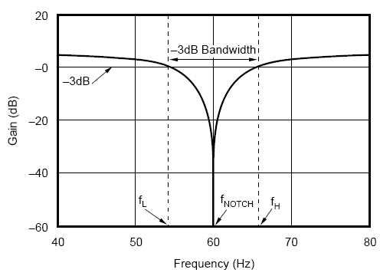
Appendix 1. The ideal frequency response curve of a 60Hz notch filter that can be built using the UAF42 chip at Q = 6.

G. REFERENCES

- http://www.frca.co.uk/article.aspx?articleid=339
- Molina J. Design a 60Hz notch filter with the UAF 42. Burr-Brown Application Bulletin. 602:746-7592
- Barr RE, Chan EKY. Design and implementation of digital filters for biomedical signal processing J. Electrophysiol. Tech. 1986 ;13:793-93.
- Universal Active Filter Burr-Brown Application Bulletin

